 

|  |
| --- |
| **FPT- APTECH COMPUTER EDUCATION** |
| eProject Report |
| Excell-On |
|  |
| |  |  | | --- | --- | | **Group 2** | | | **Group Member** | Lê Huy Đức - Student1234252  Phạm Đức Mạnh - Student1239580  Nguyễn Hoàng Sơn - Student1236284  Lê Đức Phúc - Student1251192  Bùi Văn Sinh - Student1234299 | | **Batch** | T1911E | | **Center** | FPT Aptech | | **Semester** | 3 | |
|  |

|  |
| --- |
| - Hanoi, 8/2021 - |

**Contents**

1. Acknowledgements 4

2. Introduction 4

3. Problem Definition 4

3.1. Problem Abstraction 4

3.2. The Current System 4

3.3. The Proposed System 5

3.4. Boundaries of the System 6

3.5. Development Environment 6

4. Requirements and Business Flows 7

4.1. Customer Requirements 7

4.2. Activity Diagram 8

4.3. Use Case Diagram 11

5. Design 13

5.1. System Architecture 13

5.2. Class Diagram 14

5.3. Class Diagram Explanation 15

5.4. Sequence Diagram 16

5.5. Entity Relationship Diagram 24

5.6. Database Design 26

6. Management and Project Planning 27

6.1. Management Approach 27

6.2. Project Plan 27

6.3. Task Sheet 29

7. Screenshots 31

# Acknowledgements

# Introduction

* This document is made to help our client, Excell-On and other viewers, such as Aptech center understand our product and know what benefits it may bring to the technology world of today.
* It contains information about our application, problems and solutions, diagrams and business flows, screenshots of the final product, etc...

# Problem Definition

## Problem Abstraction

Excell-On is a company in which the main business is to let other companies hire their employees as a type of service. The company has always worked directly with their customers, but as the internet is becoming more and more mainstream, they need a new way to approach more customers. They want an online application to do that job, make it easier for customers to buy their services, through just a few clicks. It needs to be all automatic, and no direct meetings are required.

## The Current System

Excell-On has segregated themselves into various branches based on the various services that they offer to their clients, so as to meet the requirements of organizations i.e., of their clients. The various branches that the Excell-on had segregated is as follows:

* In-bound Services (The In-bound service is a service in which one can only receive the calls from the customers. These call centers provide 24 hours service to all customers. The primary goal of these call centers are to receive product orders, help customers both technically and non-technically, to find dealer locations.)
  + Technical Support
  + Customer Service
* Out-bound Services (The Out-bound service is a service in which the employees of Excell-On call the customers for product promotions, for checking with the customer satisfaction on the services they provide, and for the telemarketing. Outbound Call Centers depend on the technological solutions, extensive experience, quality assurance programs and commitment to customer service excellence that further ensures maximum results from the direct marketing efforts for its success.)
* TeleMarketing Services (The Tele Marketing service is a service which is purely for the promotion of marketing or sales of the products and services.)

## The Proposed System

The application should hold the following functionalities:

**►Non-Financial:**

1. The details of the services offered are to be maintained.
2. The different department details are to be maintained. The different departments that Excell-on has is as follows:

* HR Management
* Administration
* Service
* Training
* Internet Security (It will take care of any technical related issues and problems like the PC of an employee is hanged, PC of an employee is not getting started, One of the software application is not running properly, installing and uninstalling software, etc.)
* Auditors

1. The details of the employees are to be maintained based on the designation and the services (like out-bound, in-bound, etc.)
2. The details of the charges levied for each service are to be maintained.
3. The details of the clients are to be maintained.
4. The details of the services that their clients preferred are to be maintained.
5. The details of the products and services that their clients offer (like if the client is a manufacturer of refrigerators, then the details of the different type of refrigerator they manufacture are to be maintained, and if the client is the internet service provider, then the details like the various type of the services that they offer, and they want Excell-on to promote the sales services for that company using the in-bound or out-bound services, then these details are to be maintained, etc.) are to be maintained.
6. Based on the charges levied for a service, the total charges for the clients are to be calculated based on the services that the client prefers.
7. The details of the payments as received by the client are to be maintained.
8. The reports for the late payments, payments, clients, employees based on the services, for a particular duration are to be generated.

**►Financial:**

The charges for the different services that they offer keep on varying based on the services preferred by their clients. The charge structure for the services that the Excell-on offers is as follows.

|  |  |  |
| --- | --- | --- |
| **Sr. No**. | **Service** | **Charges (per day per employee)** |
| 1 | In-bound | 4500$ |
| 2 | Out-bound | 6000$ |
| 3 | TeleMarketing | 5500$ |

## Boundaries of the System

* The database should contain the details of the services, department details, employee details, client details, the details of the services that are preferred by the clients, the product details of the clients, the payment details that are paid by the clients of Excell-on.
* One should be able to maintain the details of the charges levied for each type of service.
* One should be able to insert, update, delete and search and retrieve the records of the clients.
* The advanced search option is to be implemented so as to fetch and retrieve the records.

## Development Environment

***Development Environments:***

* Asp.Net MVC
* SQL server

***Software Requirements:***

* Internet Browsers such as Chrome, Microsoft Edge, Firefox,...
* An operating system that can run browsers (Windows, linux, Android,...)

***Hardware Requirements:***

* Any computer or phone that can run a browser and have access to the internet.

## 

# Requirements and Business Flows

## Customer Requirements

* Be able to login.
* Be able to edit their profile.
* Be able to view all services, company information, top employees,...
* Be able to book a service and make payment.
* Be able to apply a coupon code (if they have one).
* Be able to update or cancel an order if order is pending.
* Be able to view all of their orders (including their cancelled, finished, or pending orders).

## Activity Diagram

***Customer book a service:***

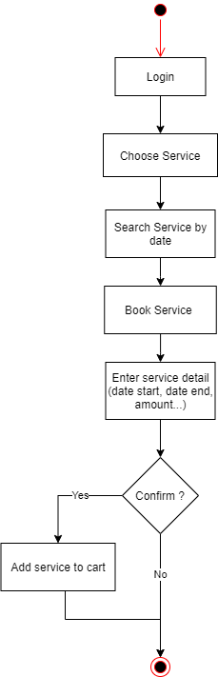

***Customer Checkout:***

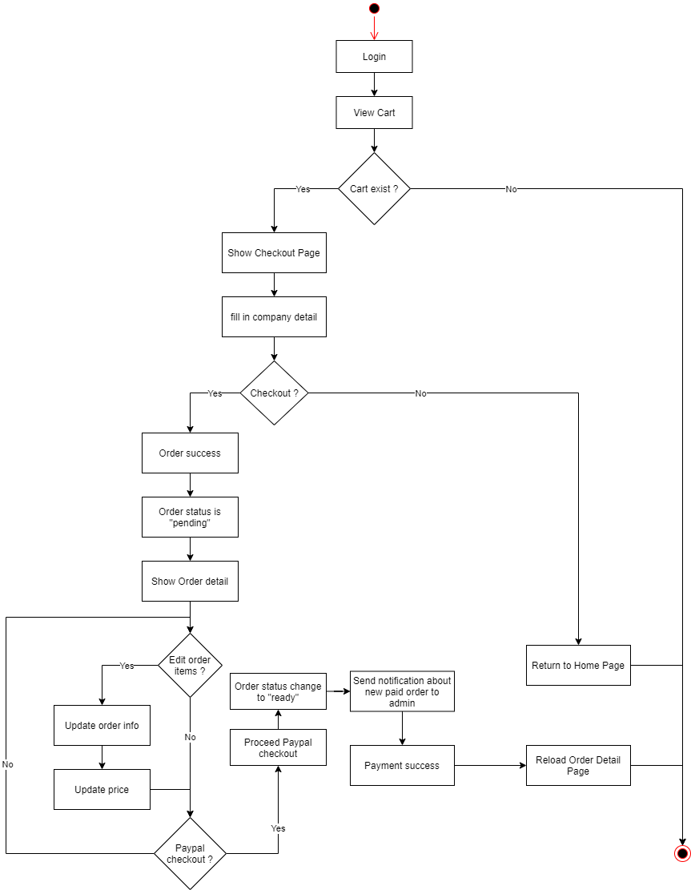

***Admin or manager activate order:***

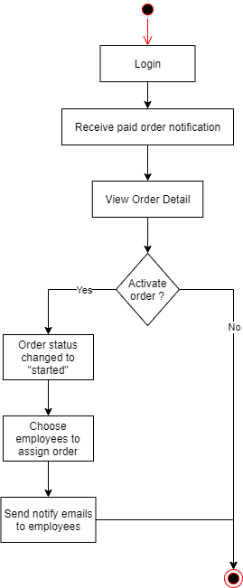

## Use Case Diagram

***Customer Use Case:***

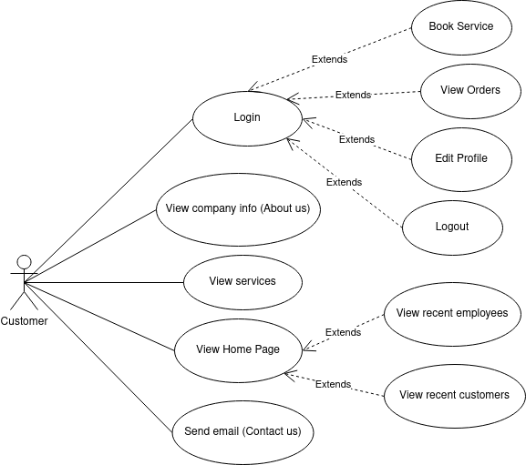

***Company Use Case:***

1. All Users:

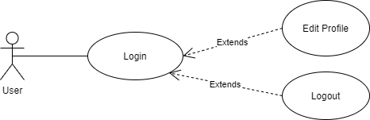

1. Employee:

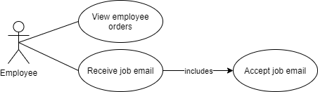

1. Departments (Or CMS):

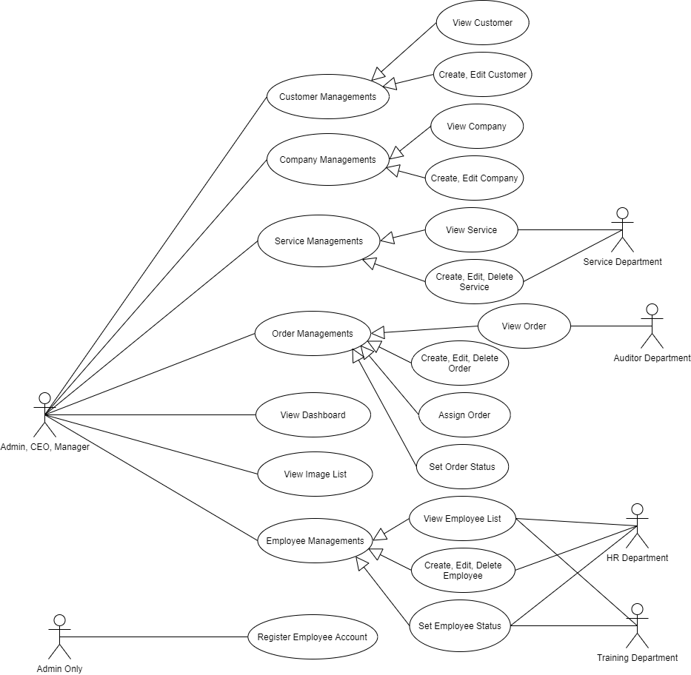

# Design

## System Architecture

Our System uses the basic design architecture similar to most well-known E-commerce systems or booking systems such as flights, hotel rooms, etc…

## Class Diagram

***1. CMS:***

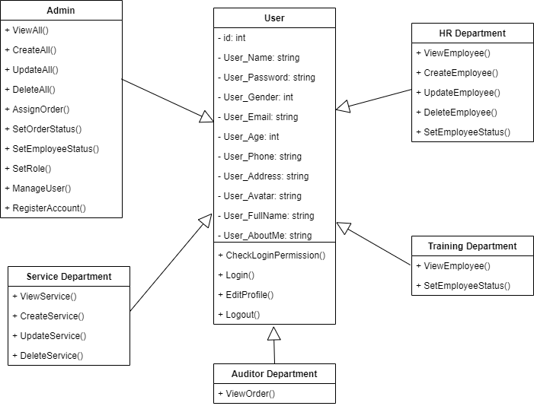

***2. End-user System:***

*Note*:* *We changed the class names from “Employee” to “Staff” because “staff” is shorter and helps us save coding time. We also did this in our database and our actual codes.*

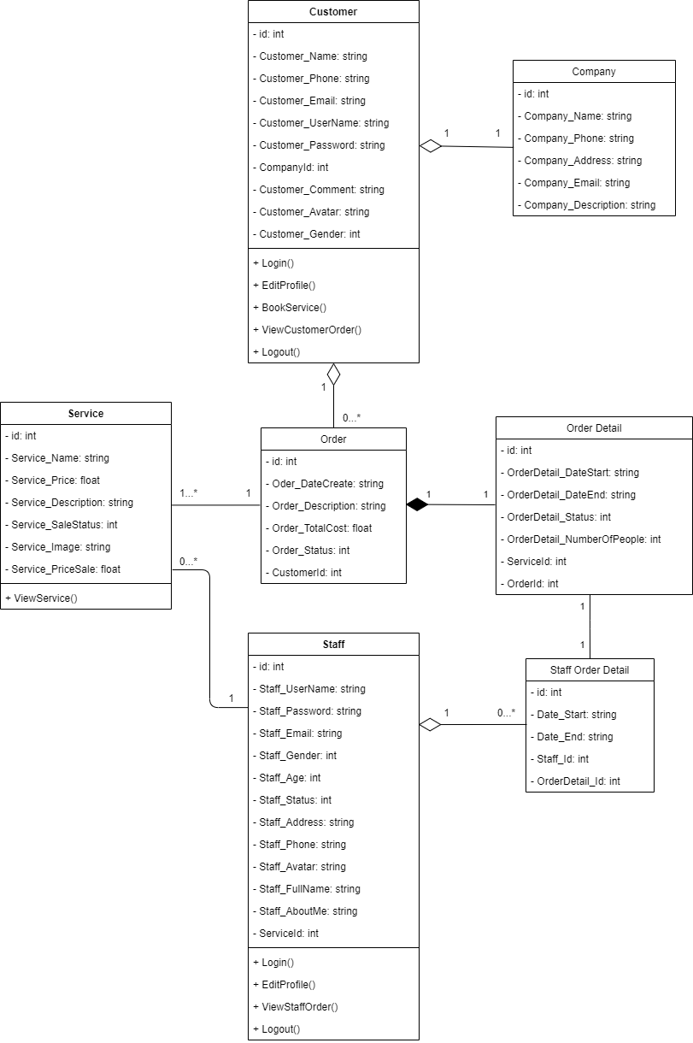

## Class Diagram Explanation

1.CMS:

This Class Diagram is used for the CMS side of our system. Inherited from class “User” are classes that are corresponding with each role of the CMS system. Based on the class that “User” inherited, this “User” will have access to each area in the system. For example, an user inherited “Service Department” class can only see the service area and do things such as create, update, delete in this area, while “Admin” can see all areas and do a lot of things.

2.End-User system:

This Diagram represents the End-User system. Classes “Customer” and “Staff” represent the users of this system.

Class Explanation:

* Class “Staff” (or Employee) is considered End-User because staff are not allowed to change anything in the system. They can only view which order they were assigned to and view emails about their job.
* Class “Company” is optional and can be filled in after a customer's account is signed up, hence the aggregation relationship.
* A customer can have many orders or no order, hence aggregation again, they also can’t exist without each other, so composition relationship.
* Customers can order all 3 services at once, so 1-many relationship between “Order” and “OrderDetail”,and 1-1 relationship between ”Service” and “OrderDetail” is set.
* Reason the class “Staff Order Detail” exists is to get the OrderDetail_Id that was assigned to the particular staff and to show it in the staff order view.

## Sequence Diagram

***Login (For All User):***

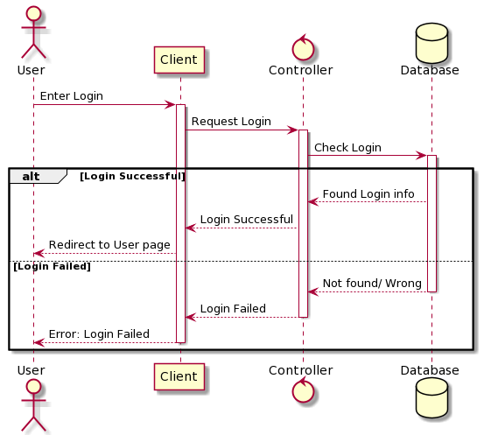

***Add service to cart (For Customer):***

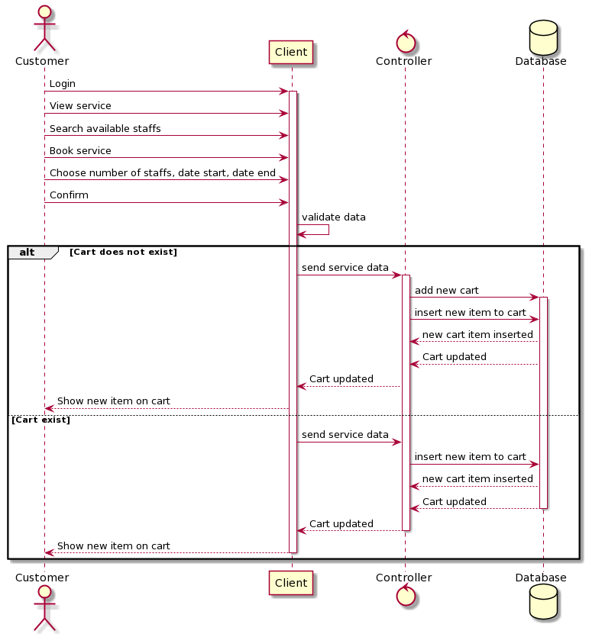

***Checkout (For Customer):***

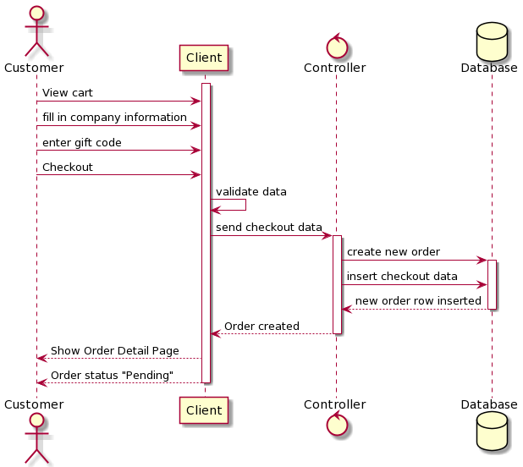

***Paypal Checkout (For Customer):***

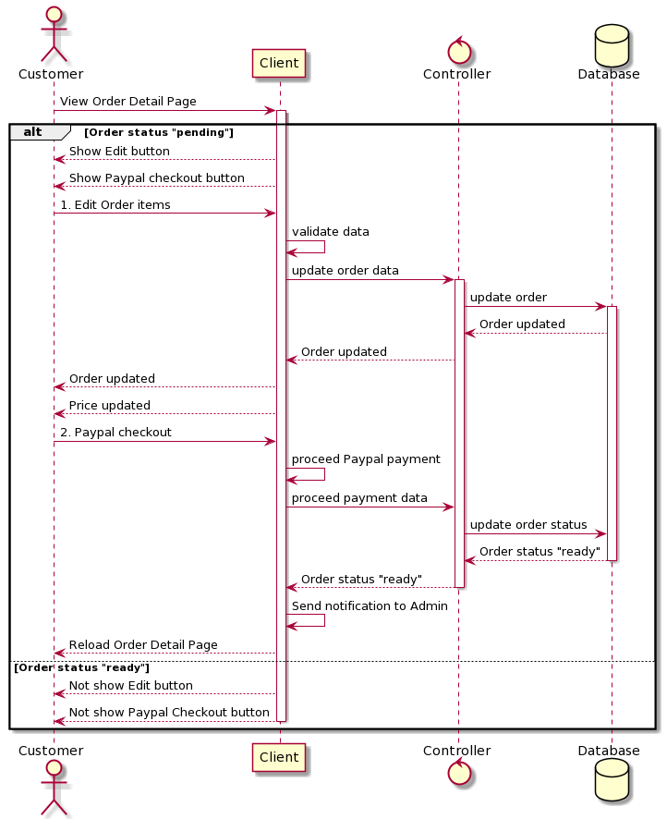

***Activate Order (For Admin or Manager):***

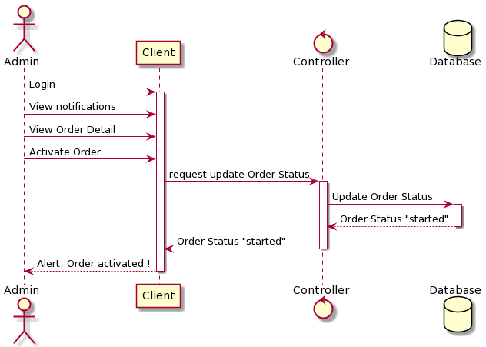

***View (For CMS User):***

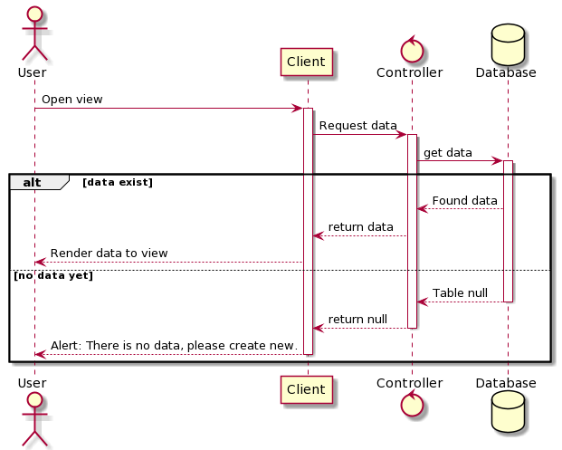

***View (For Customer and Staff):***

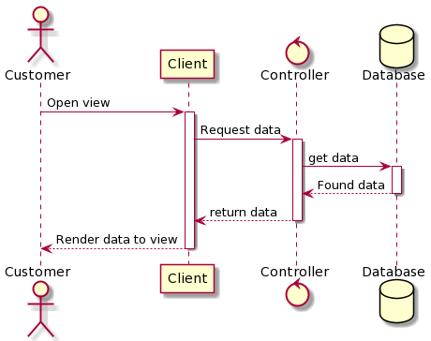

***Create (For CMS User):***

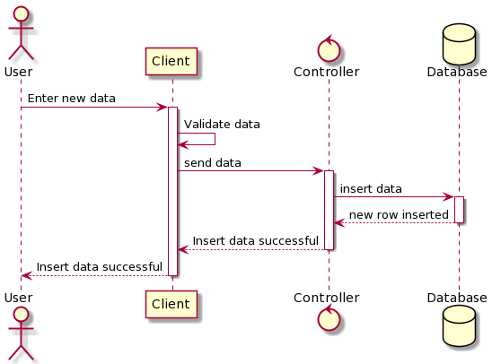

***Update (For CMS User):***

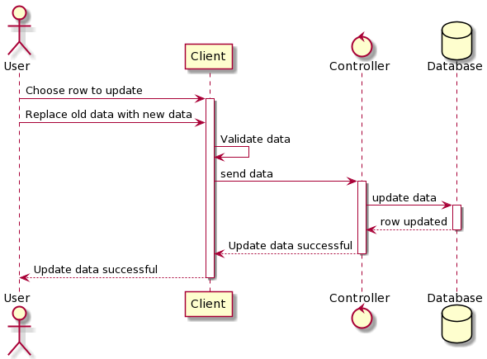

***Delete (For CMS User):***

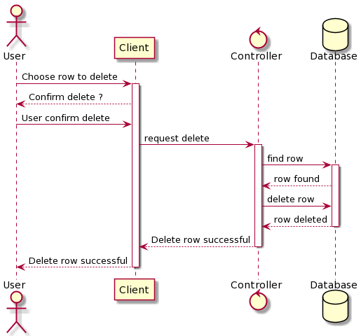

***Print file (For CMS User):***

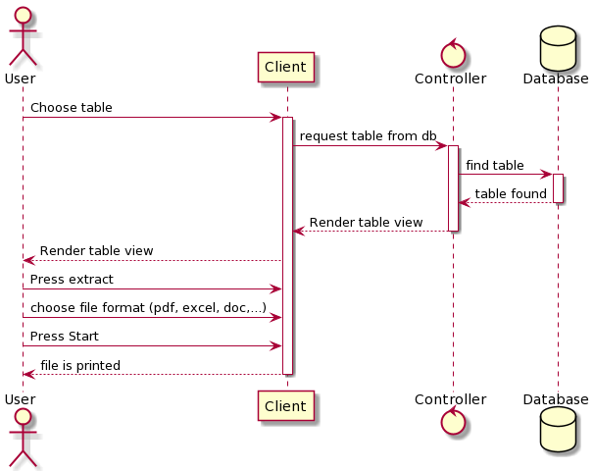

***Send email (For CMS User):***

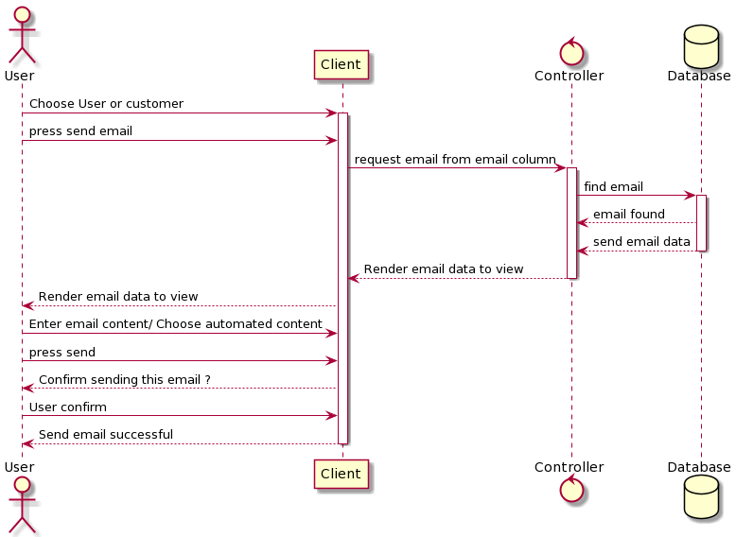

## Entity Relationship Diagram

***User-Role-Permission ERD:***

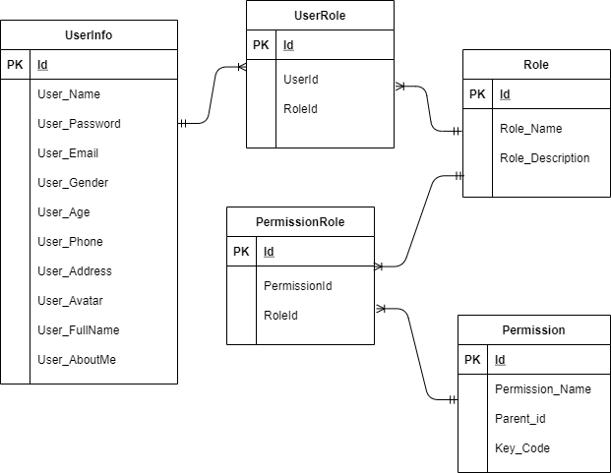

***Main ERD:***

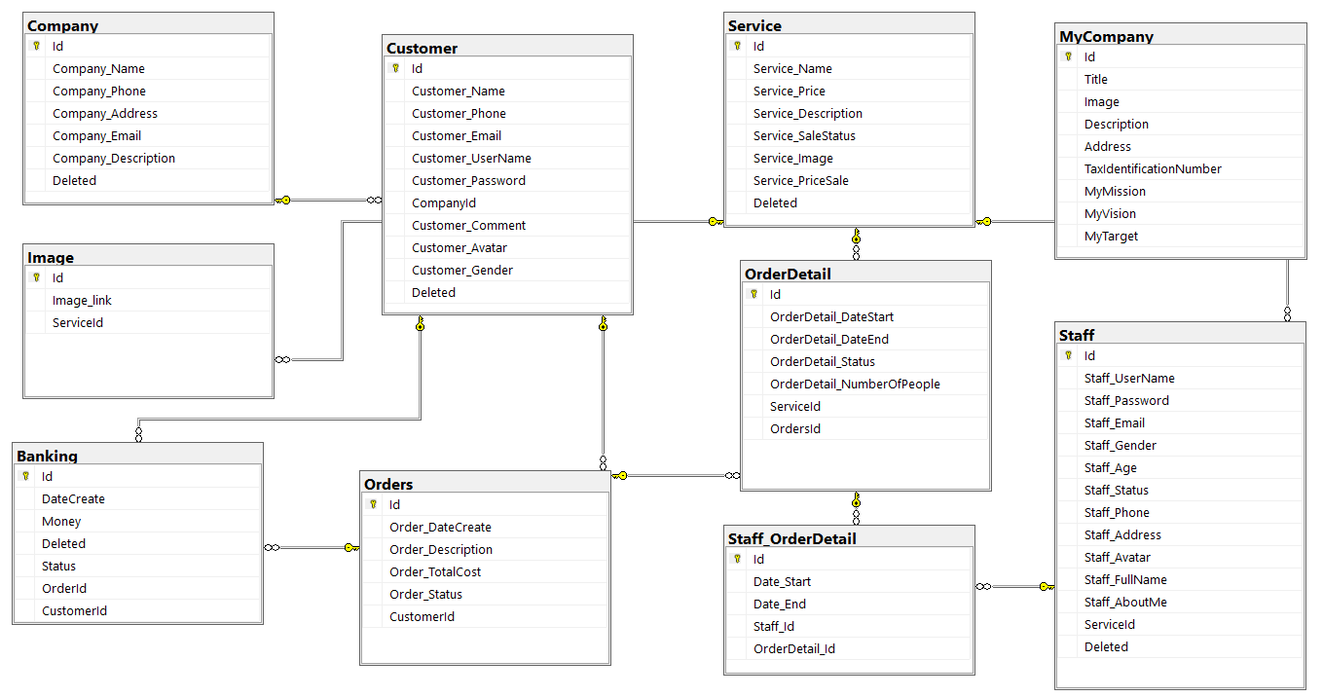

## Database Design

***User-Role-Permission Database:***

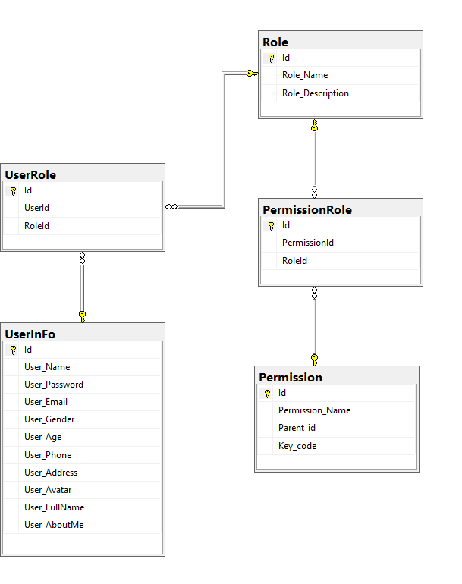

***Main Database:***



# Management and Project Planning

## Management Approach

Our team is self-managed most of the time. We always vote during our meetings to decide which tasks are the most important to focus on, then each member chooses their task (We follow scrum framework). We often meet 3-4 times a week to share our work, discuss next steps and help each other fix bugs if there are any.

## Project Plan && Task Sheet

***link :***[***Group2-Backlog-Project-sem3.xlsx - Google Sheets***](https://docs.google.com/spreadsheets/d/1DJFB-ROYEk-H2KsIhFo7lzT6r6eO4JhtyByn3wVJkBQ/edit#gid=536049027)

# Screenshots

***User Interface***

* ***Login Customer***

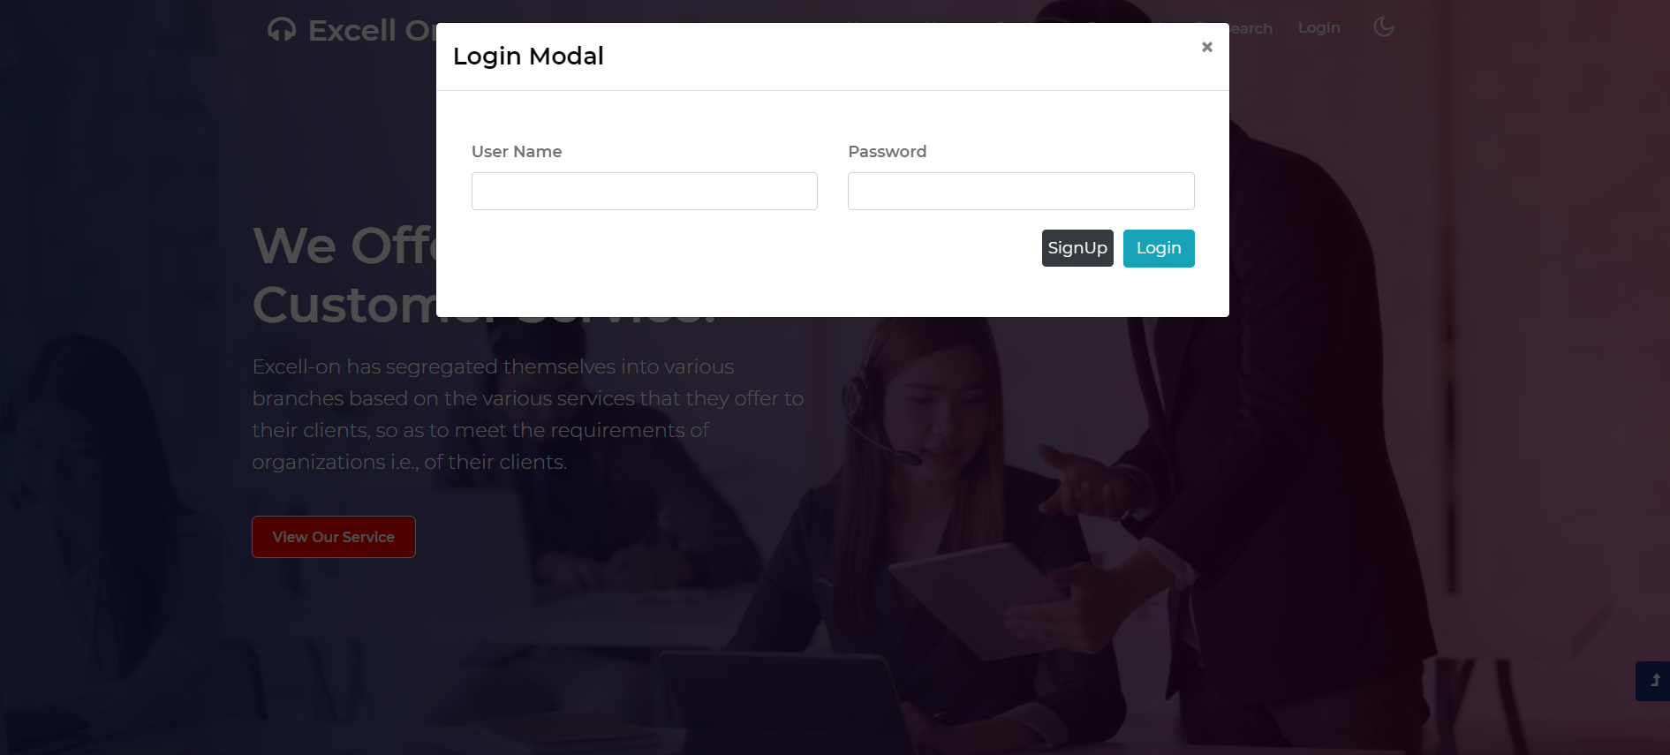

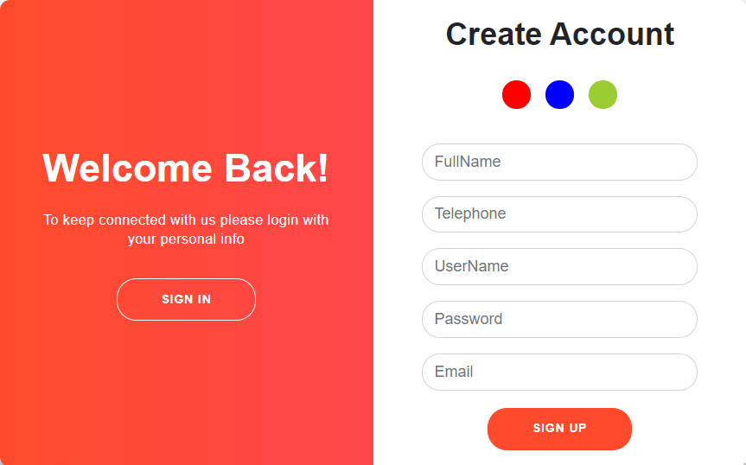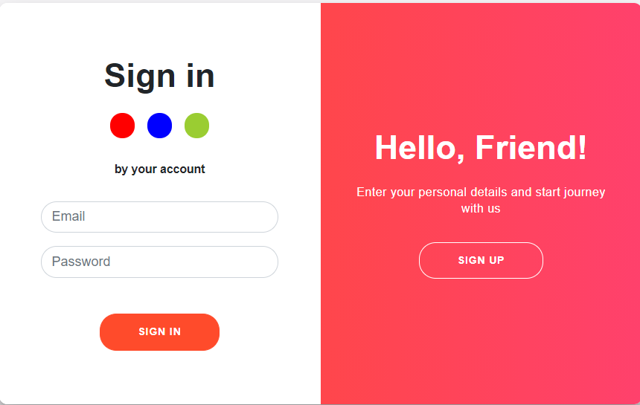

* ***Home***

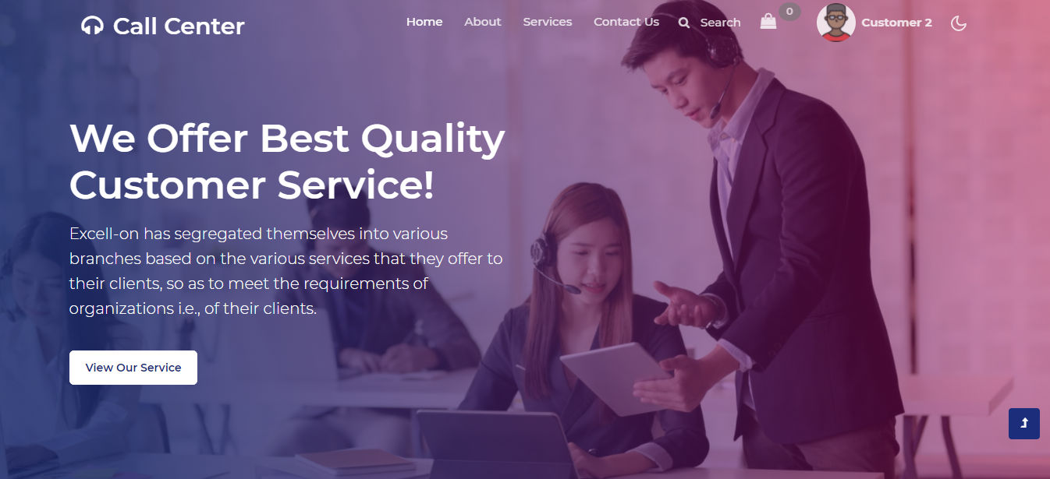

## 

* ***About Us***

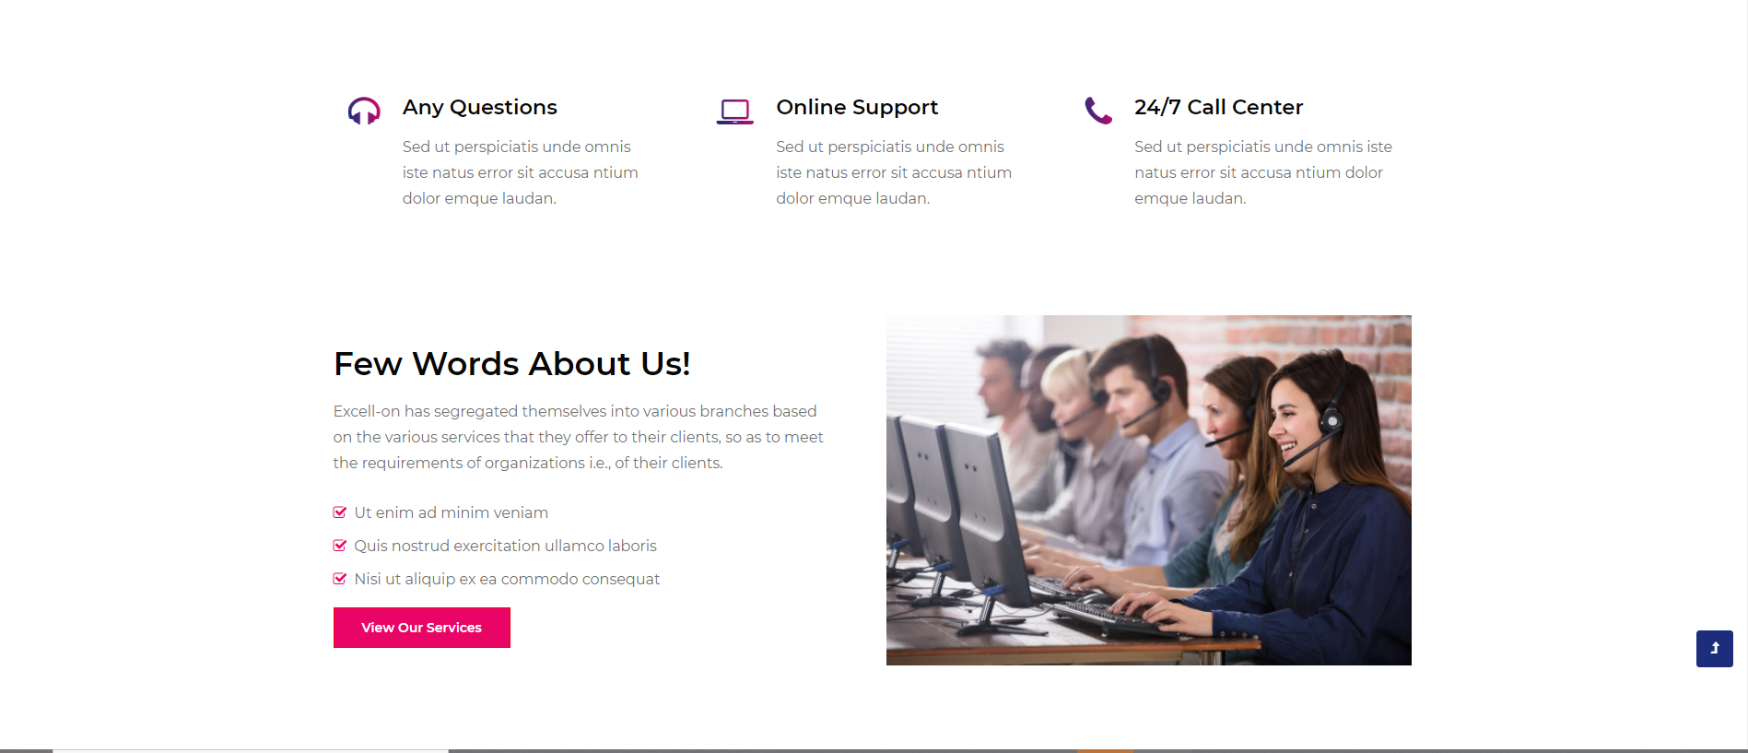

* ***Service***

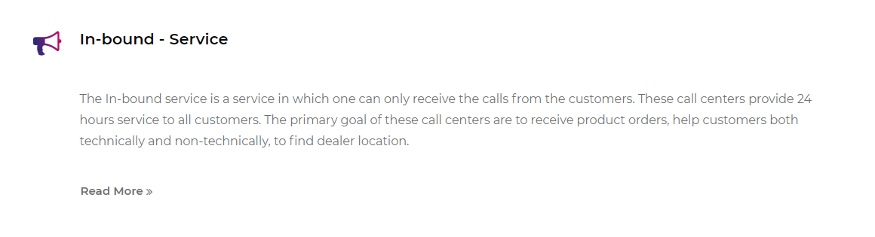

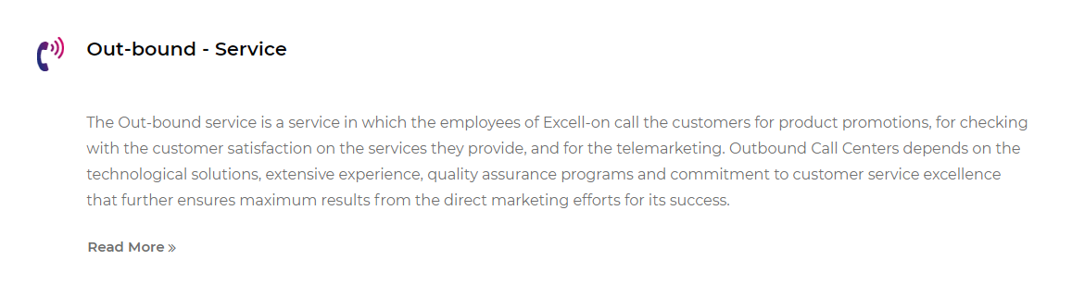

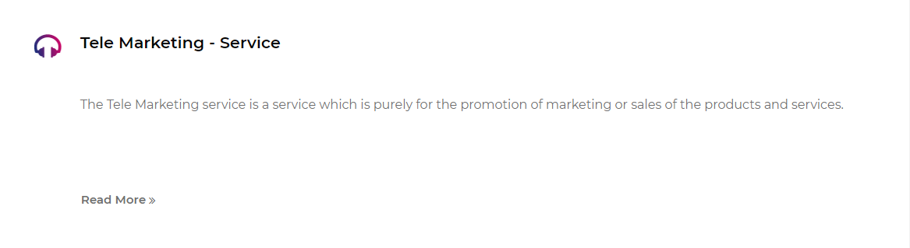

* ***Contact Us***

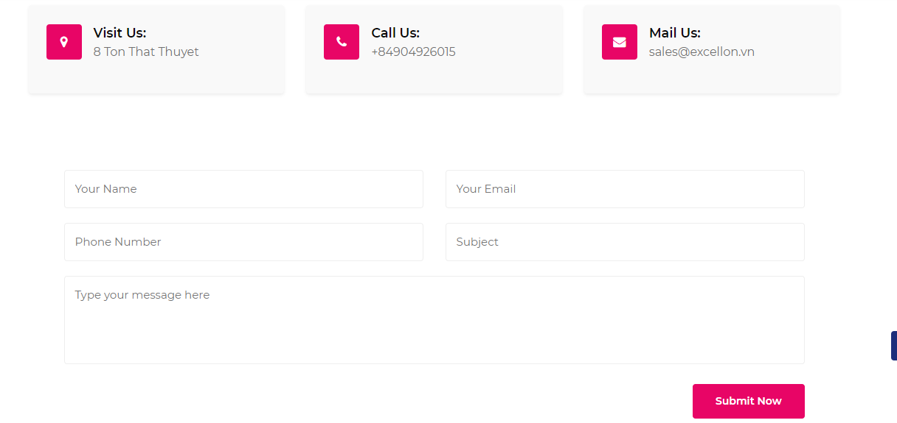

* ***Search***

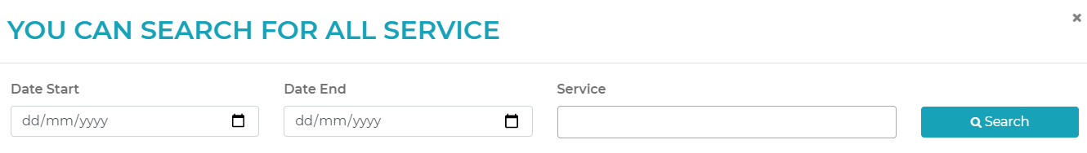

* ***Result Search***

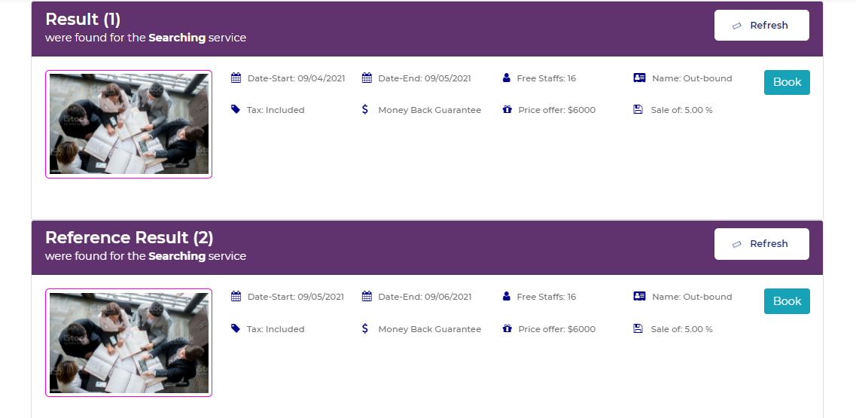

* ***Customer Profile***

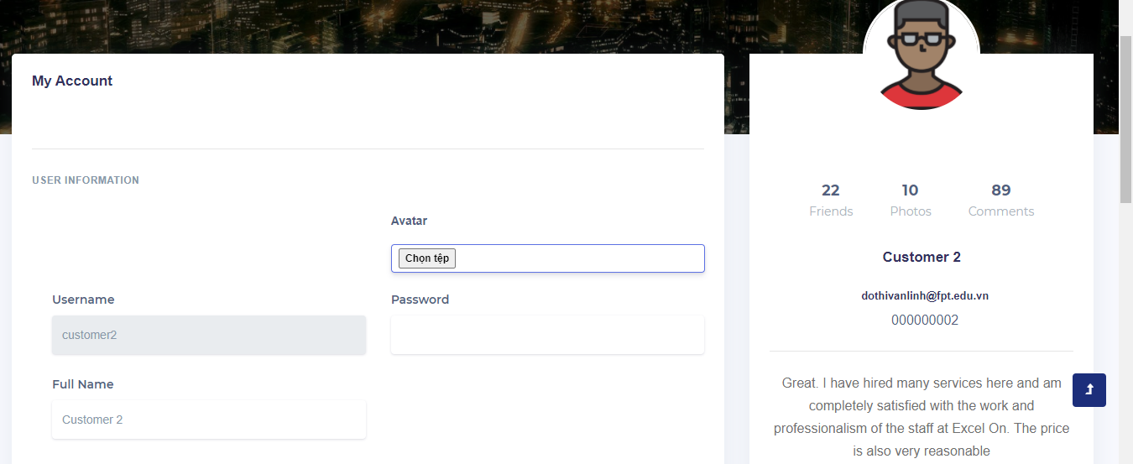

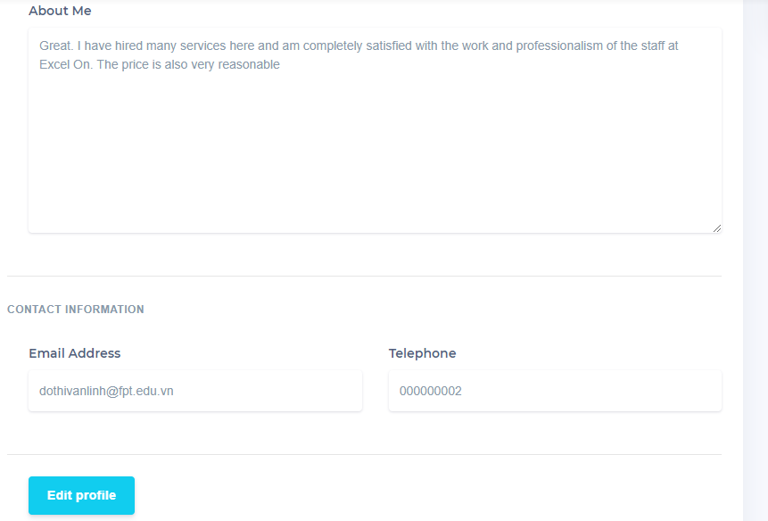

* ***Customer OrderList***

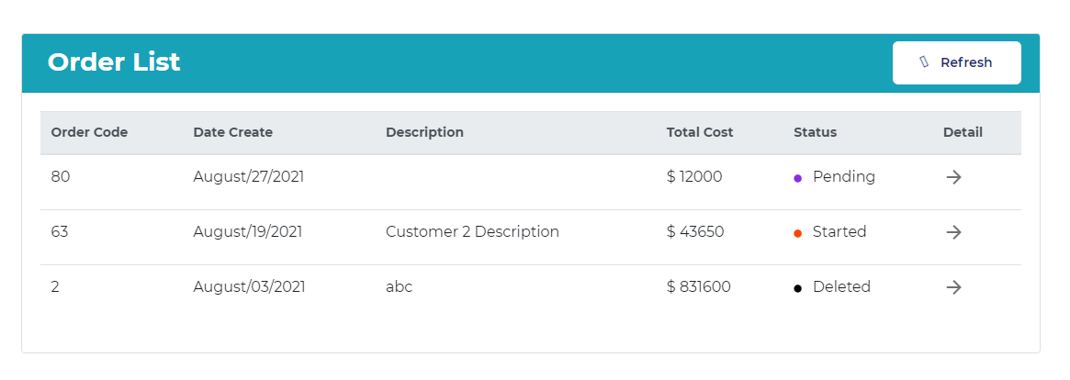

* ***Customer OrderDetail***

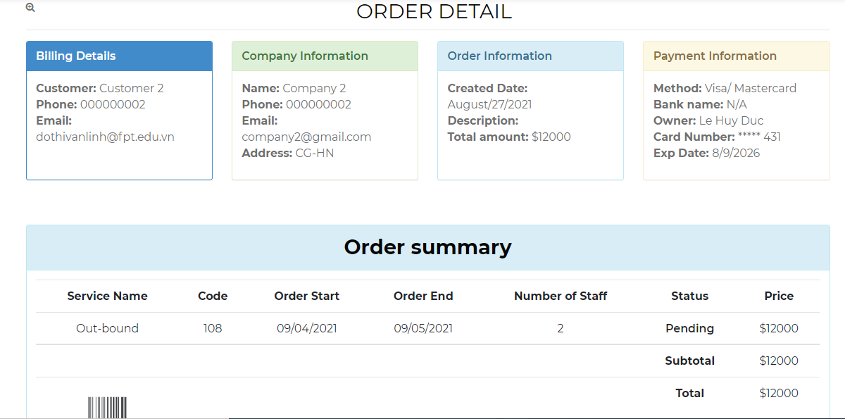

* ***Order***

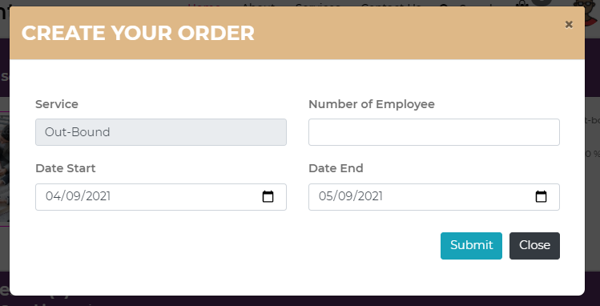

* ***Cart***

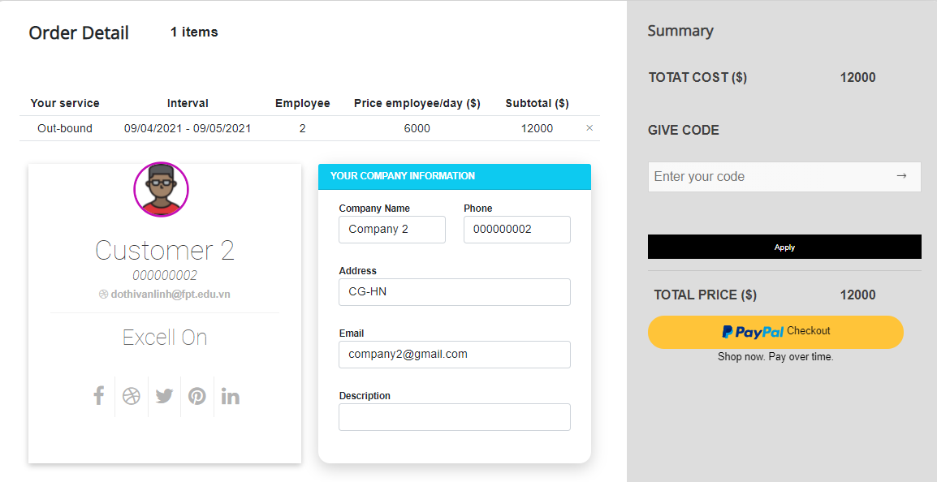

* ***ADMIN***
* ***Admin Login***

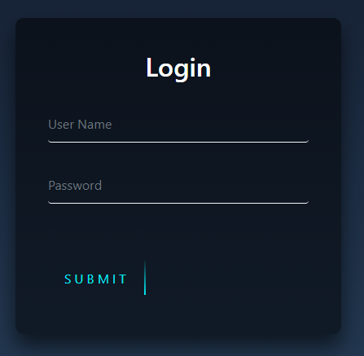

* ***AdminHome-Dashboard***

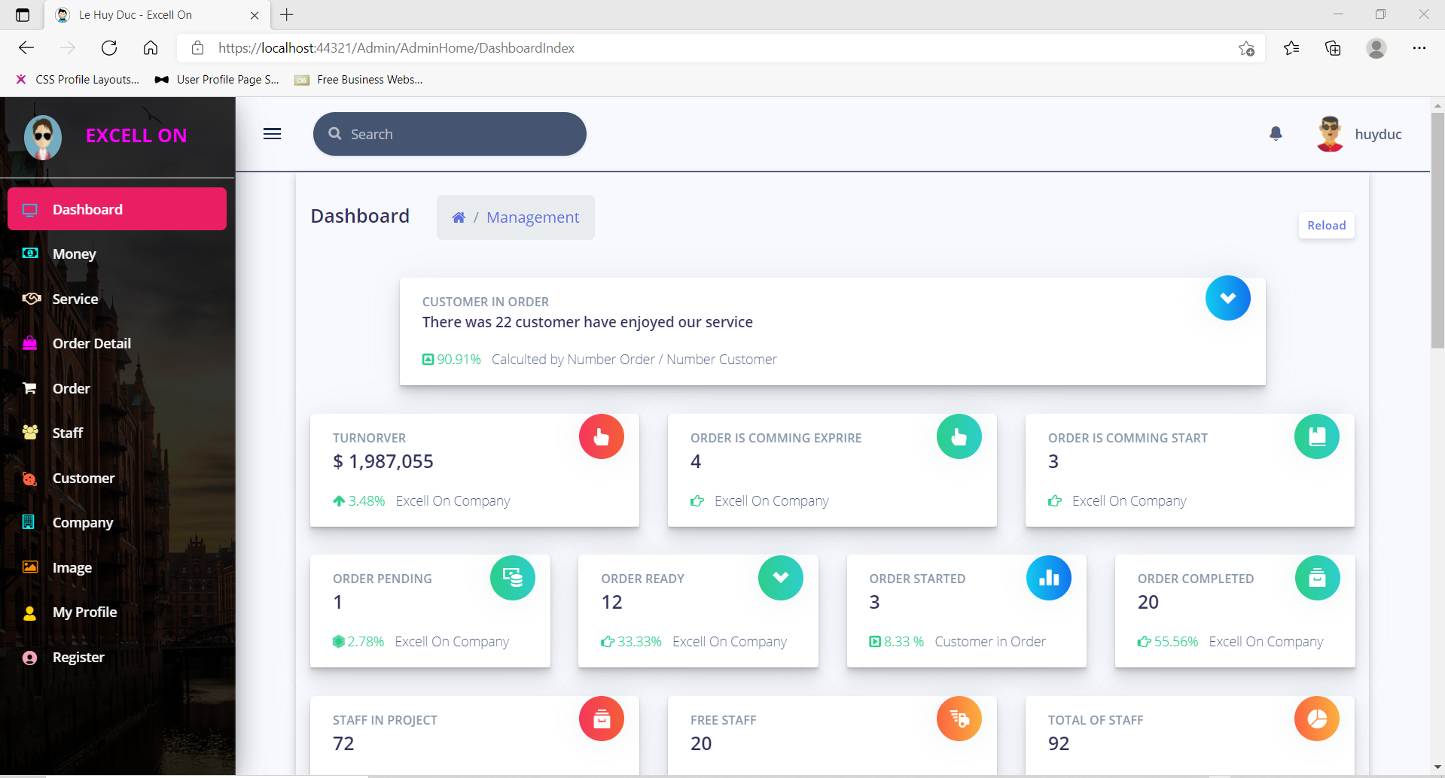

* ***ServiceManagement***

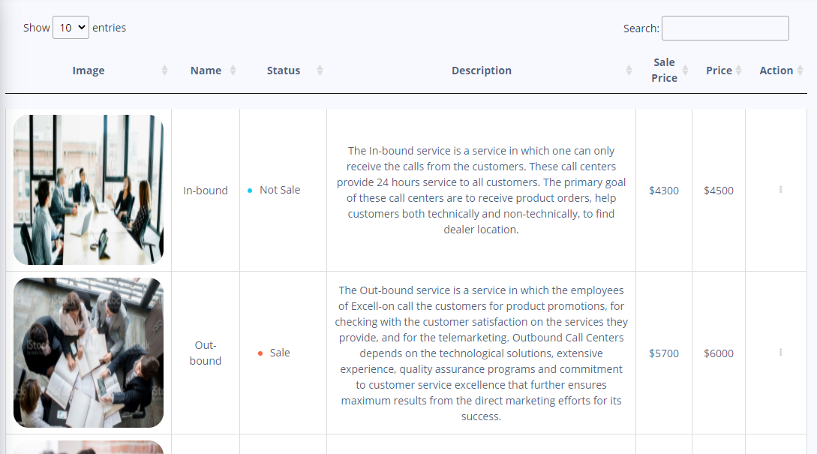

* ***OrderDetailManagement***

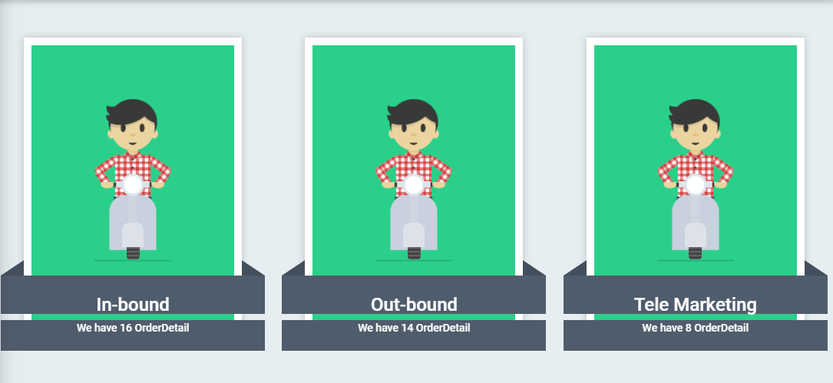

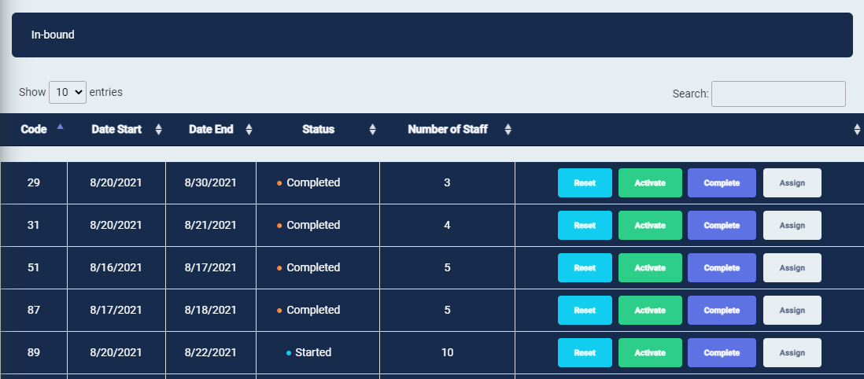

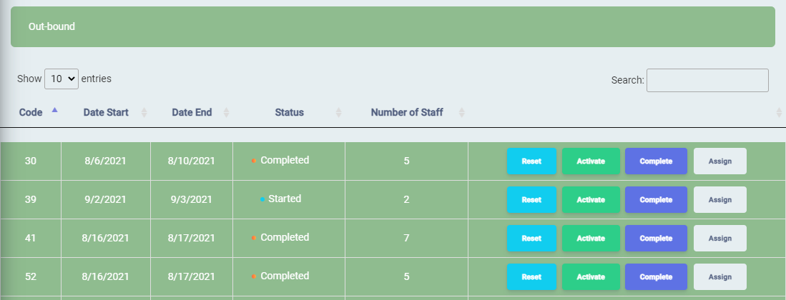

* ***OrderManagement***

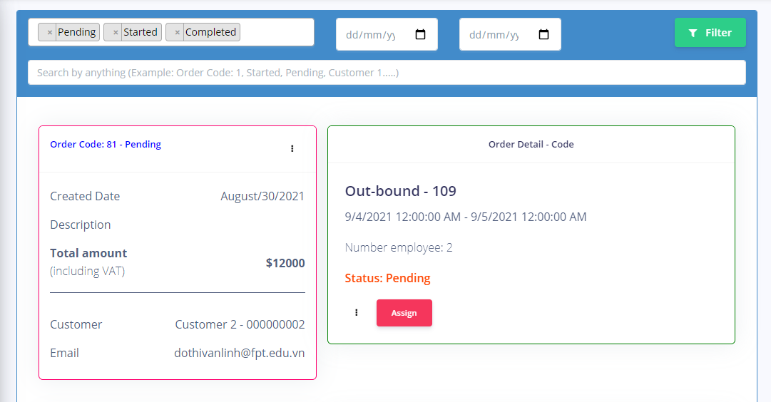

* ***StaffManagement***

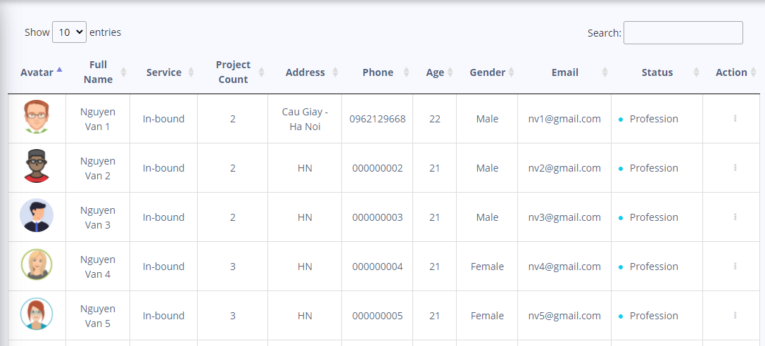

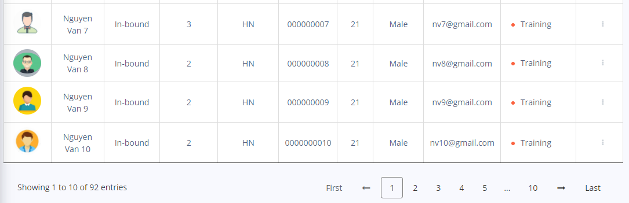

* ***CustomerManagement***

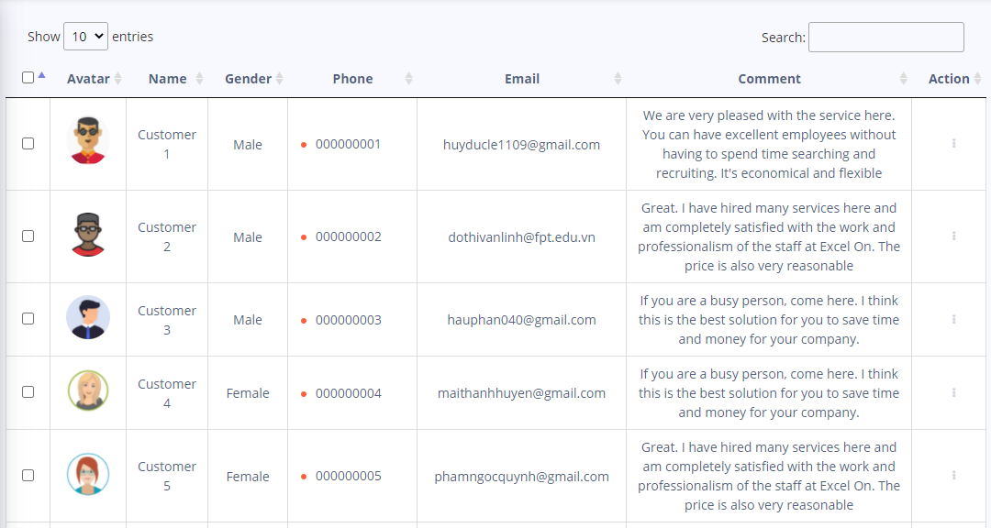

* ***CompanyManagement***

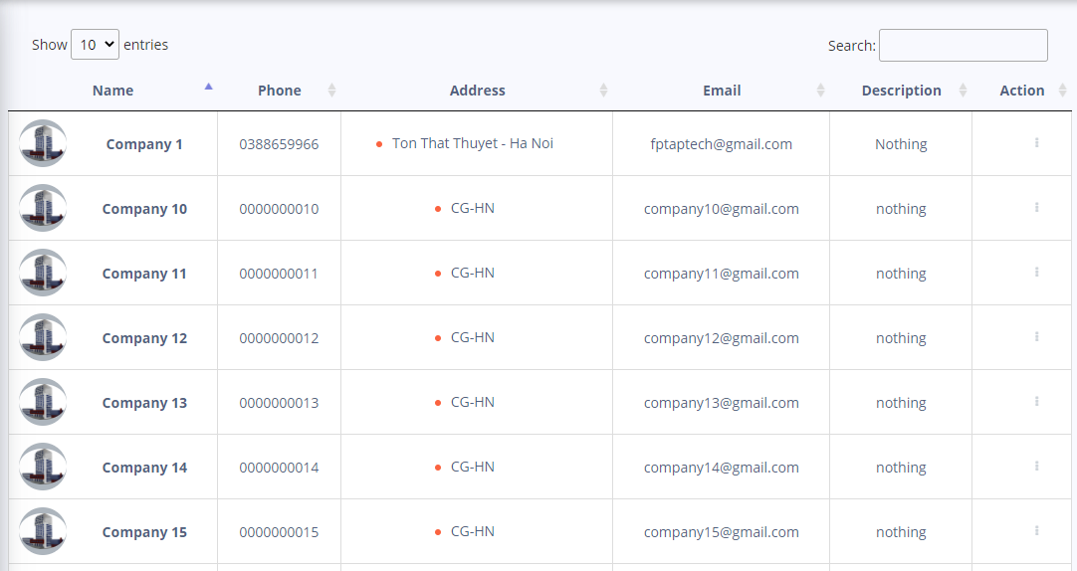

* ***ImageManagement***

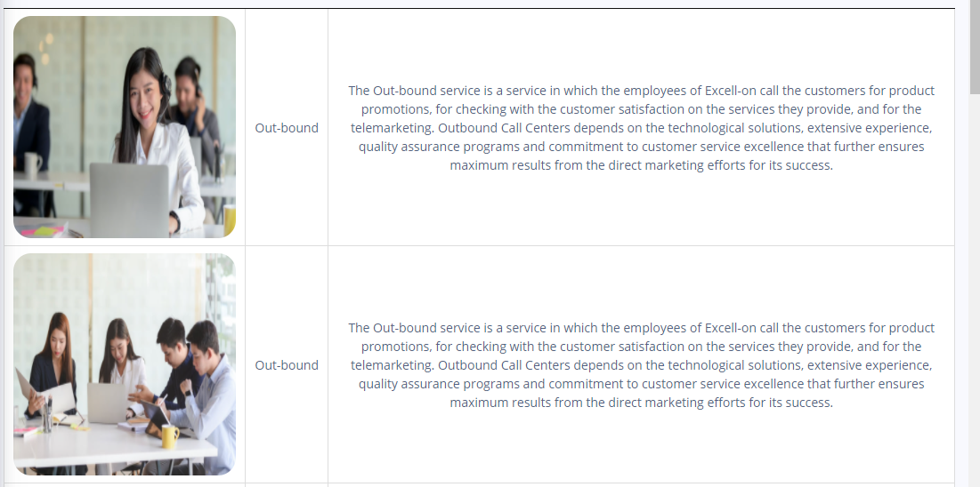

* ***RegisterEmployee***

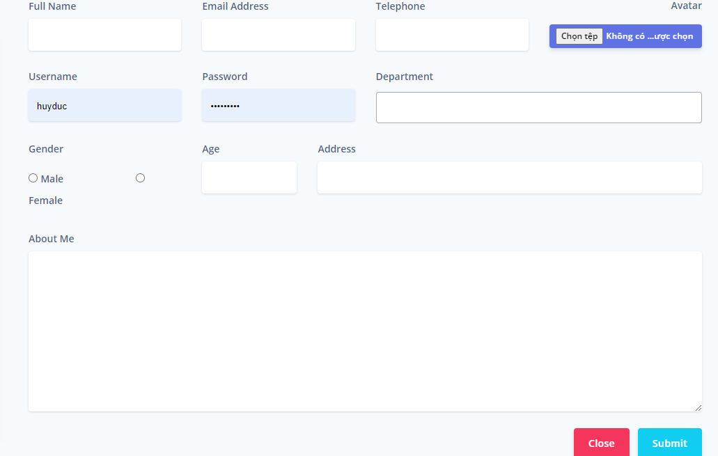

* ***RoleManagement***

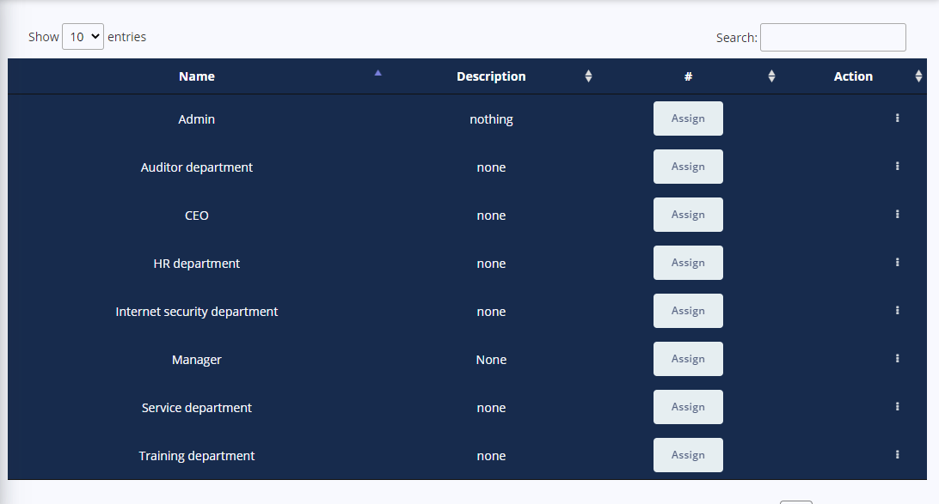

* ***UserManagement***

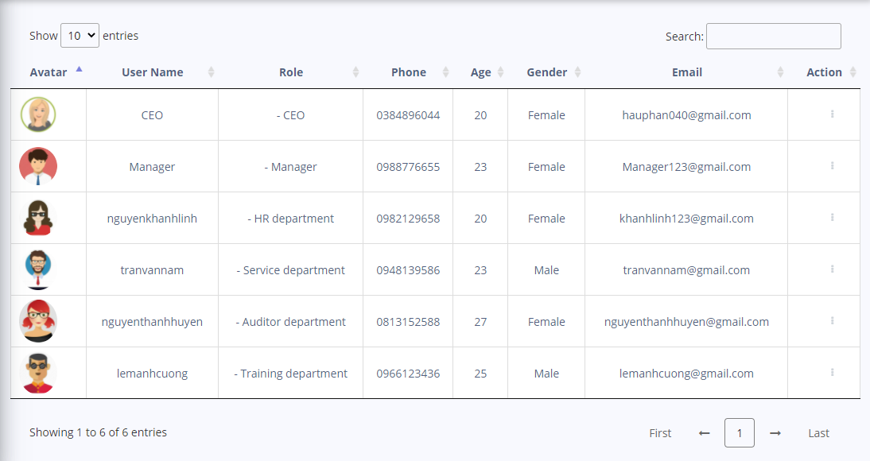

* ***StaffLogin***

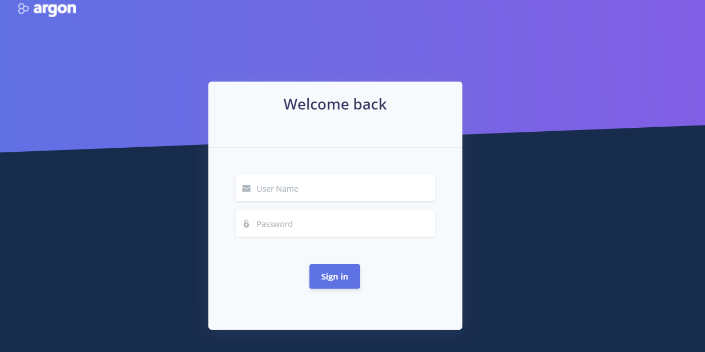

* ***ProfileStaff***

